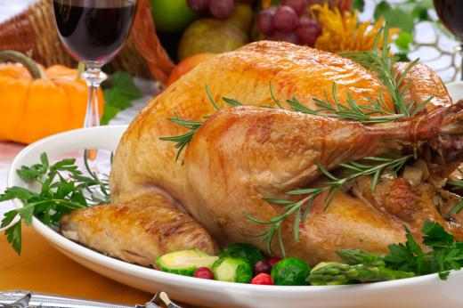

**Classic Roast Turkey**

**Ingredients**

1 frozen turkey  
1 lb butter  
3 cups chicken stock  
2 cups stuffing  
1 tsp Dried sage  
1 tsp dried thyme  
A couple rosemary stocks  
2 tsp salt  
1 tsp pepper

**Preparation**

1) Thaw your turkey. It takes about 24 hours per 5 pounds, so we thaw ours for 3 days.   
  
2) Wash your thawed turkey inside and out. Pat it dry with a towel. If you brine your turkey, this is the time to do it. Brining takes 24 hours. This recipe doesn't use a brine.   
  
3) Preheat your oven to 325F. Pull out your roasting pan and grease it well.   
  
4) Prep your turkey by pulling out all the extra feathers. Take out that turkey popper (they're useless).   
  
5) Mix 1/2 of the butter with the sage, thyme, salt, and pepper, and mash it into a paste. Liberally coat the turkey inside and out with the butter. Put as much as possible under the skin on the breasts.   
  
6) Tie your turkey up to keep the wings and legs in place. Put the stocks of rosemary around the bird. This will give the meat a fragrance without the overpowering flavor.   
  
7) Loosely pack the stuffing inside the bird. Don't pack it in or else it won't cook.   
  
8) Put your turkey on the roasting pan and pour in 2 cups of chicken stock and 1/2 cup butter into the bottom of the pan. Place the turkey in the oven.  
  
We use smaller turkeys but the general rule is that a 12 pound turkey gets 3.5 hours in the oven.   
  
9) Every 45 minutes, baste the turkey with the stock mixture in the bottom of the pan. If it ever boils off then add the last cup of stock. If the turkey gets too brown, cover it with foil.  
  
10) The turkey is done when you hit an internal temperature of 170-180. Let the bird rest for 30 minutes before you cut it.

* Prep Time: 30 Min
* Cook Time: 120 Min
* Difficulty: Easy
* Serves: